 Answers to review questions from Chapter 8

1. In your own words, describe the recursive insight necessary to solve the Towers of Hanoi puzzle.

**In the Towers of Hanoi puzzle, the complete solution to moving a stack of *N* disks can be subdivided into three steps:**

**1. Moving a stack of *N* – 1 disks from the start spire to the temporary spire**

**2. Moving the single disk at the bottom from the start spire to the finish spire**

**3. Moving the stack of *N* – 1 disks from the temporary spire to the finish spire**

2. The following strategy for solving the Towers of Hanoi puzzle is structurally similar to the strategy used in the text:

a. Move the top disk from the start spire to the temporary spire.

b. Move a stack of *N*–1 disks from the start spire to the finish spire.

c. Move the top disk now on the temporary spire back to the finish spire.

Why does this strategy fail?

**This strategy fails to obey the rule that a larger disk may not be placed on top of a smaller one.**

3. If you call

moveTower(16, 'A', 'B', 'C')

what line is displayed by **moveSingleDisk** as the first step in the solution? What is the last step in the solution?

A -> C

. . .

C -> B

4. What is a *permutation?*

**A *permutation* is a reordering of objects from a set.**

5. In your own words, explain the recursive insight necessary to enumerate the permutations of the characters in a string.

**The set of all permutations of a string can be generated by taking every possible starting letter and then appending all possible permutations of the remaining *N* – 1 letters.**

6. How many permutations are there of the string **"WXYZ"**?

**24**

7. What simple case is used to terminate the recursion in **Mondrian.cpp**?

**The area of the rectangular canvas is less than some predetermined minimum.**

8. Draw a picture of the order‑1 fractal snowflake.

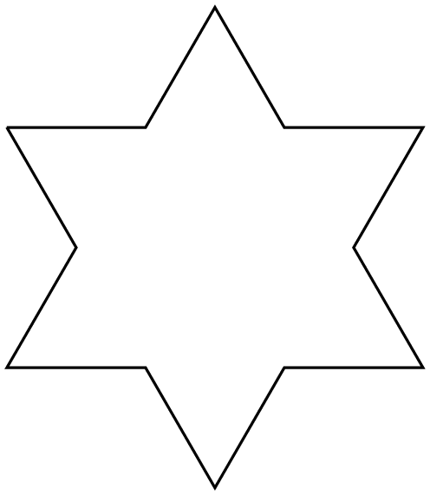

9. How many line segments appear in the order‑2 fractal snowflake?

**48**